St. Joseph Rayong School
First ^{Semester}: Midterm Examination School Year 2015-2016
Subject: Elective Science Class: Primary 2
******************************************************************************************************

Name: ……………………………………………………………….. P……../……… Student No………………………..
A. PLANTS: Circle the correct letter. (1 point each)

1. 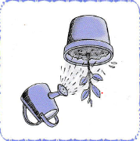 a. some water b. no water c. plenty of water d. oxygen
2. 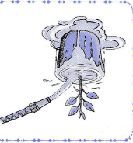 a. plenty of water b. some water c. no water d. air
3.  a. no water b. some water c. plenty of water d. wilt
4.  a. air b. nutrients c. carbon dioxide d. light
5. 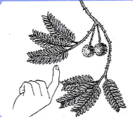 a. Touch b. sunlight c. die d. environment
6. 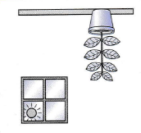 a. Light b. Touch c. air d. nutrients
2/3
B. USES OF PLANTS.
Direction: Label the uses of plants correctly. (5 Points)
Food medicines decoration materials

1. 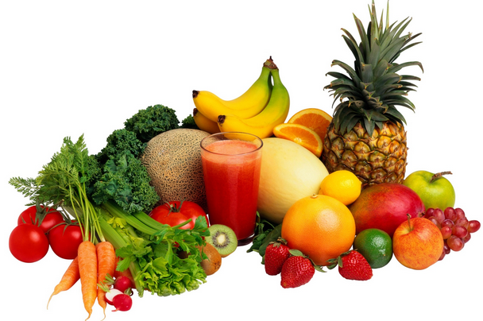 3. 
__________________________ __________________________

2. 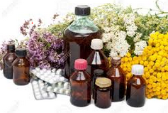 4. 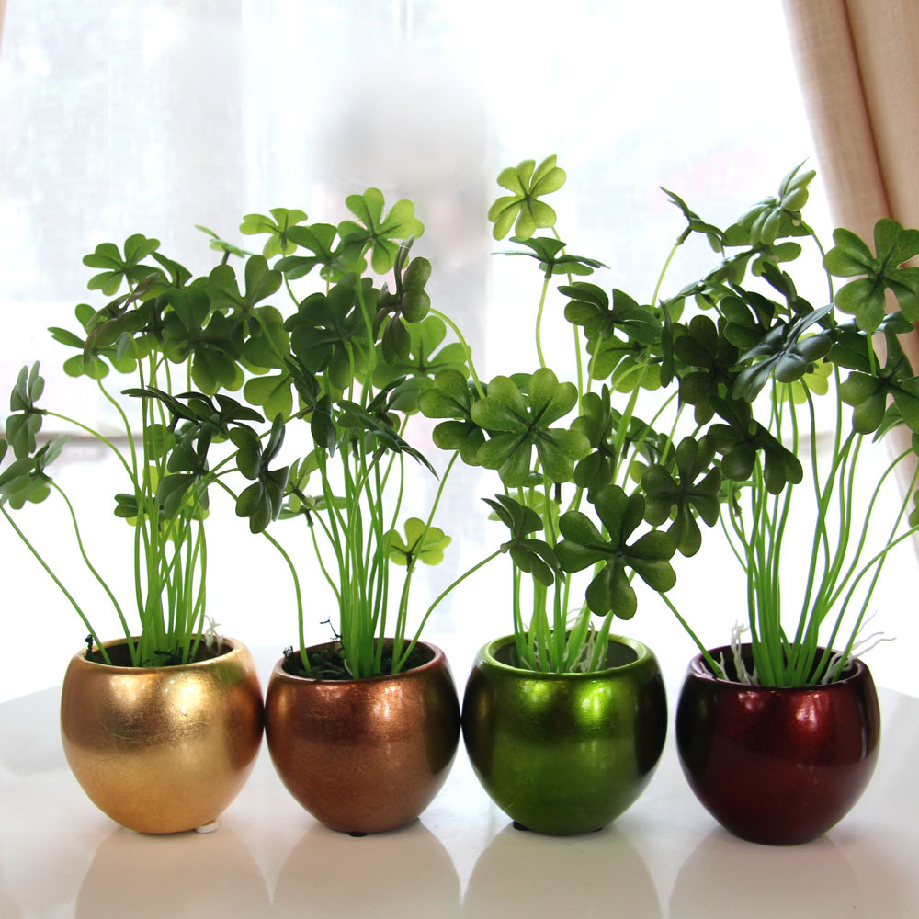

___________________________ _____________________________

C. ANIMALS
Direction: Match the needs of animals. (5 points)

1. Air

2. Food

3. Water
- 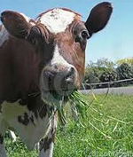

- 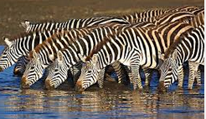

- 

3/3
D. ANIMALS FOOD.
Direction: Group the animal according to the food they eat. (5 points)

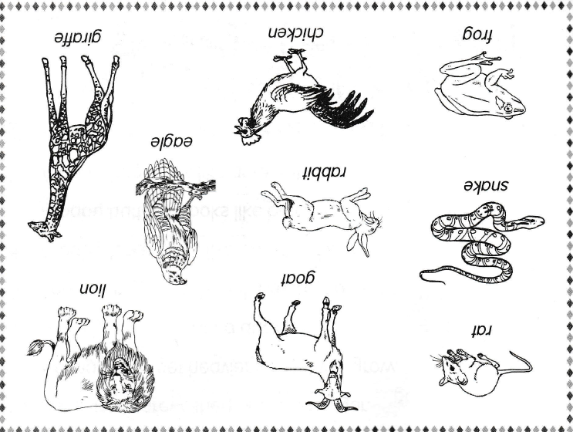

Animals that eat  plants only | Animals that eat other animals only. | Animals that eat other animals and plants

St. Joseph Rayong School
First ^{Semester}: Final Examination School Year 2015-2016
Subject: Elective Science Class: Primary 2
************************************************************************************************

Name: ……………………………………………………………….. P……../……… Student No……………………
PART I. OURSELVES
Direction: Read and match the phrases to the correct pictures. (1 point each)
1. Energy food a. 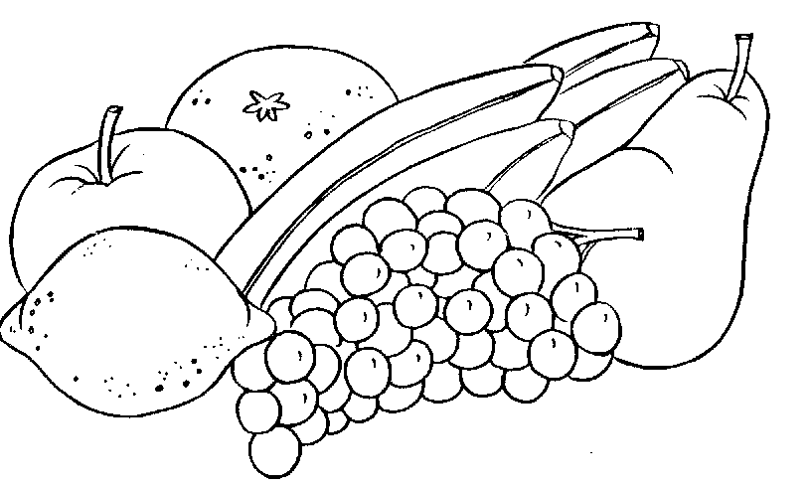
2. Grow food b. 
3. Healthy food c. 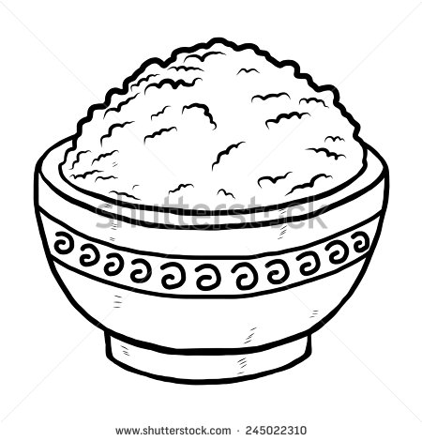
4. We need air d. 
5. We need water e. 

PART II. STIMULUS
Direction: Look at the picture and encircle the letter of the correct stimulus. (1 point each)
6. 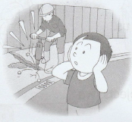 a. too noisy b. falls down c. dusty d. hot object

7. 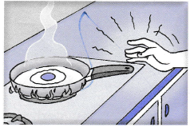 a. hot object b. too noisy c. dusty d. falls down

2/2
Subject: Elective Science Class: Primary 2
************************************************************************************************

8. 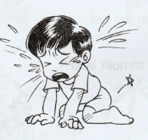 a. falls down b. hot object c. dusty d. too noisy
9.  a. cold b. hot c. garbage d. noisy
10. 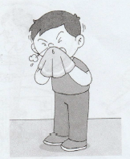 a. dusty b. delicious food c. cold d. sneeze
PART III.
Direction: Label the pictures. Choose your answer in the word bank. (1 point each)

Loamy Soil Clay Soil Sandy Soil

11. 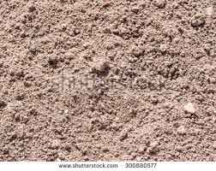 12. 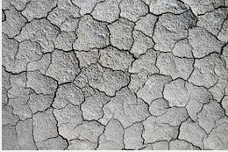 13. 
____________________ ___________________ __ ____________________
14. 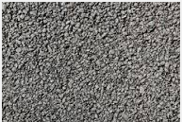 15.  16.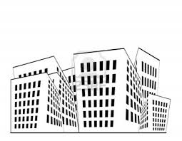

___________________ ___________________ ____________________
PART 14. Underline the correct answer.
17. (Loamy soil, clay soil) is the best soil to grow to grow vegetables.
18. Soil generally has (a few, many) uses.
19. Plants need soil for (nutrients, food).
20. (loamy, Clay) holds a lot of water.

